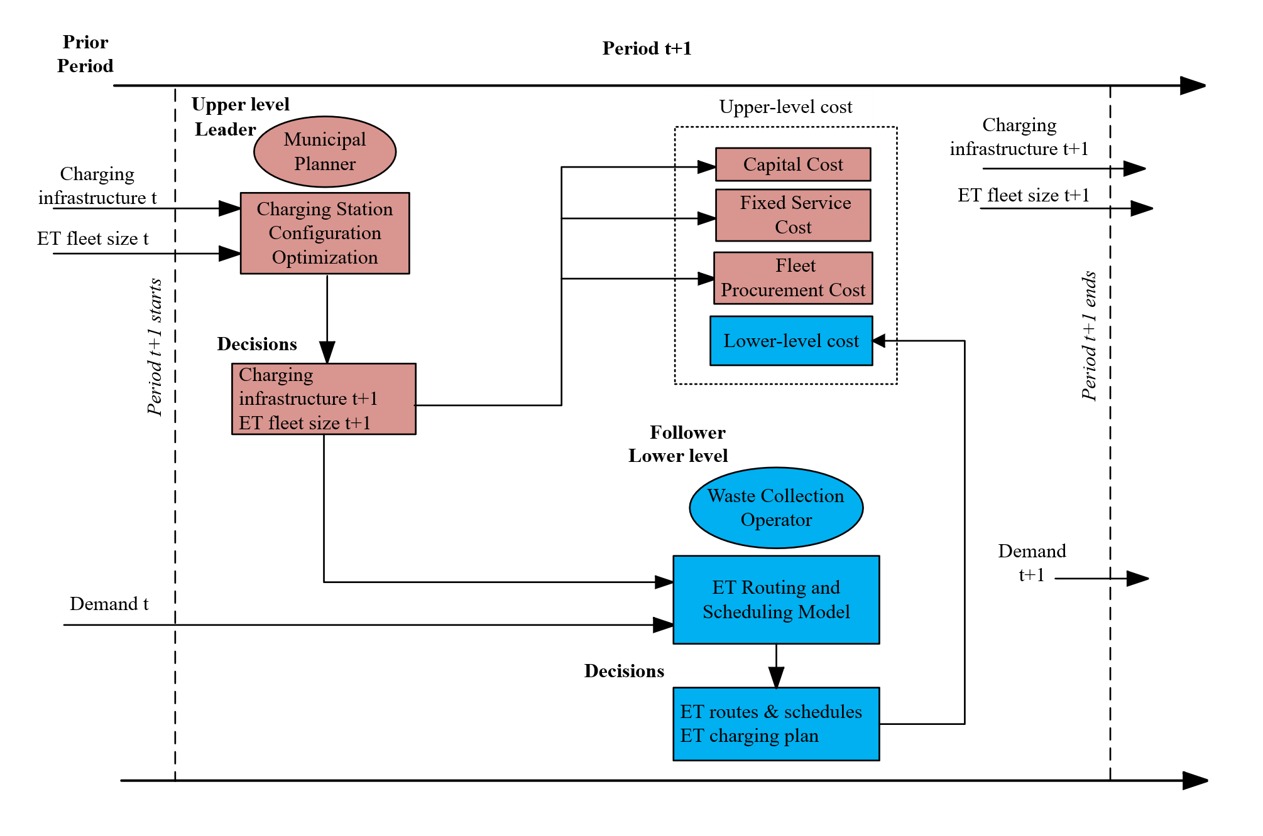
Interactions between upper-level and lower-level decisions in a charging infrastructure planning problem

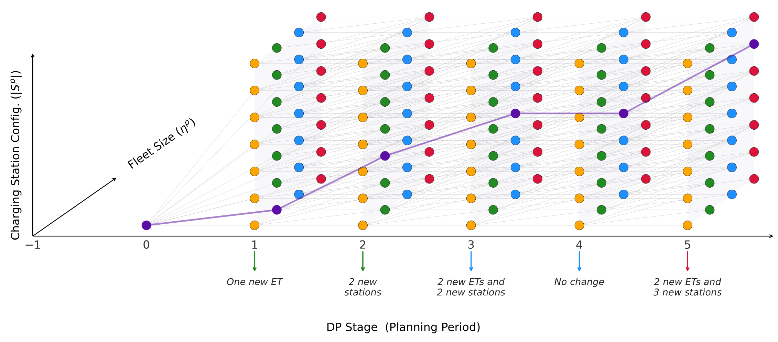
Illustration of an infrastructure planning path in DP algorithm, involving constructing new charging stations and purchasing new ETs

